|  |
| --- |
|  |
| MENT-CARE SYSTEM |
| Audit Report |
|  |
| **TEAM MEMBERS:**  **Manish Reddy Challa – JC733252**  **Phani Sanjay Varma Mudunuri – JC648751**  **Prajay Reddy – JC686931** |
|  |

|  |
| --- |
|  |

**Group Members:**

We are team of 3 members. We worked together throughout the project. We divided the project based on our knowledge.

1. **Manish Reddy (Architect and Backend development and Documentation)**

Manish Reddy contributed to the project as an Architect. Manish have gathered and documented the requirements, including key objectives, functional requirements, and content requirements, and I worked as backend developer for this project. I used MySql to create multiple tables, database, and inserted data into tables for the Mentcare system.

1. **Phani Sanja Varma Mudunuri (Front End Development and Presentation):**

Phani Sanja Varma Mudunuri contributed to the project as a front-end development. Sanja varma used HTML, CSS for the mainly for website development. Sanja varma used most of the PHP scripts to interact with Database and all the navigations and interaction of website using PHP. According to modules presented by the Architect.

Phani sanja varma prepared the all the presentation that we submitted still now. He will work for future that related to any type presentation if required that related to ict project.

1. **Prajay Reddy (Testing and Audit Report):**

Prajay Reddy used to assure the quality as well. Prajay Reddy had tested each and every module of the Mentcare system, and even tried stress testing. Tested many combinations of data as input and as per my view and my test results he issued a green signal saying that the product is ready to deliver.

Prajay Reddy prepared the audit report and tested all the test case. He will finalize the project that was ready to lunch in the market.

**Screen-shots (or illustrations) of running FINAL-release**

We divided 4 modules in mentcare system:

1. Clinical Staff
2. Administration
3. Record Manager
4. Health Services Manager

**MentCare System Index or landing page of site:**

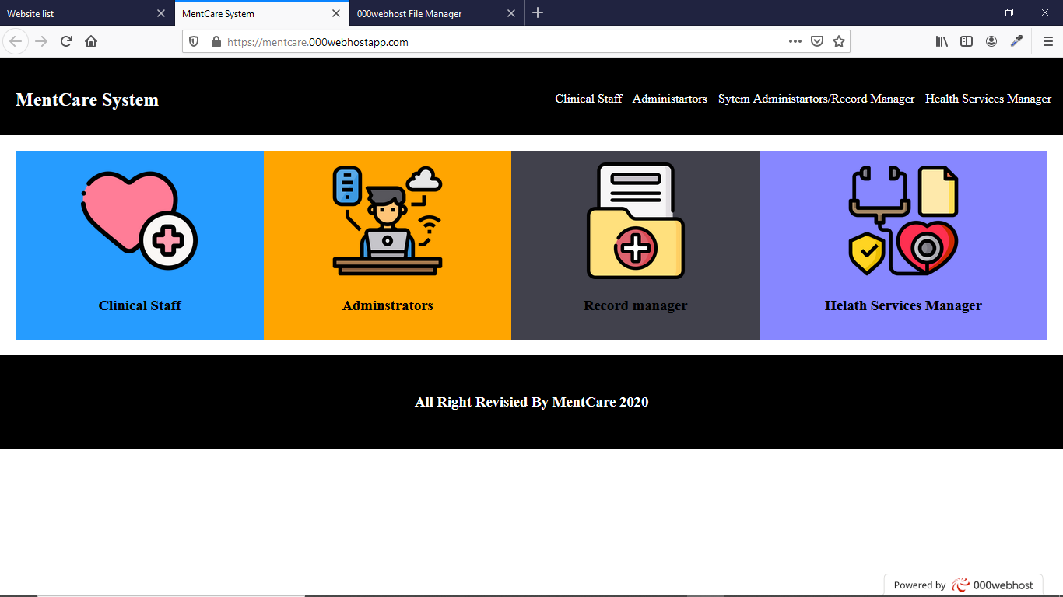

**CLINICAL STAFF INDEX:**

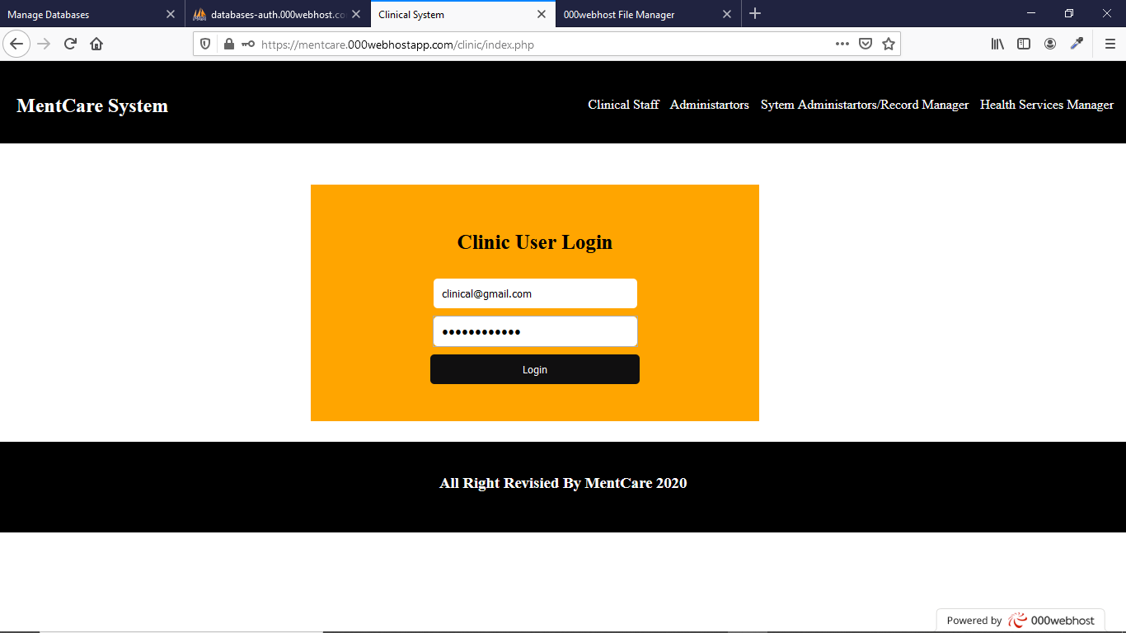

In this index page, clinical users can be log in to their module. Users can login there module with authentication. The authentication data match the data in the database. Then this page will redirect to the clinical home page.

**CLINICAL HOMEPAGE:**

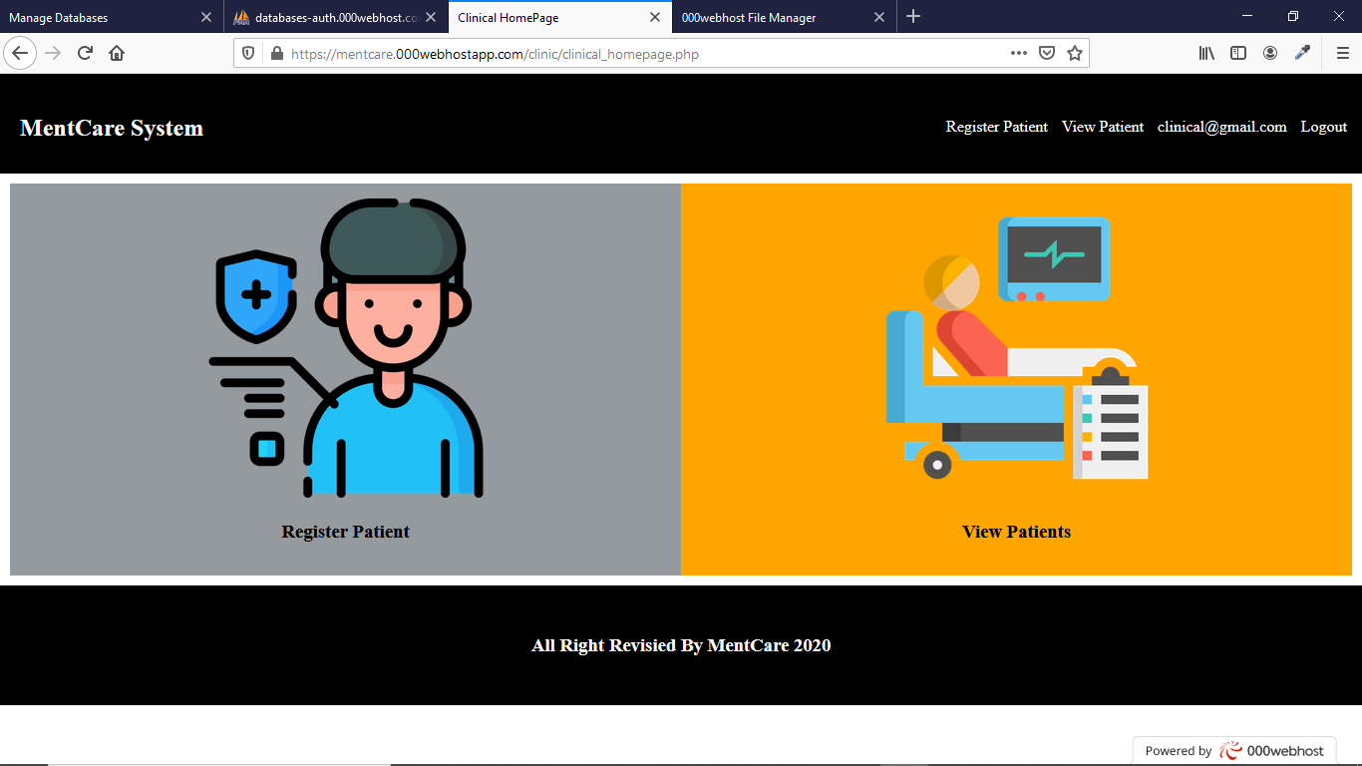

In the clinical home page have the operation which is assign to the clinical staff.

Like: register a patient, view patient details

**PATIENT REGISTRATION PAGE:**

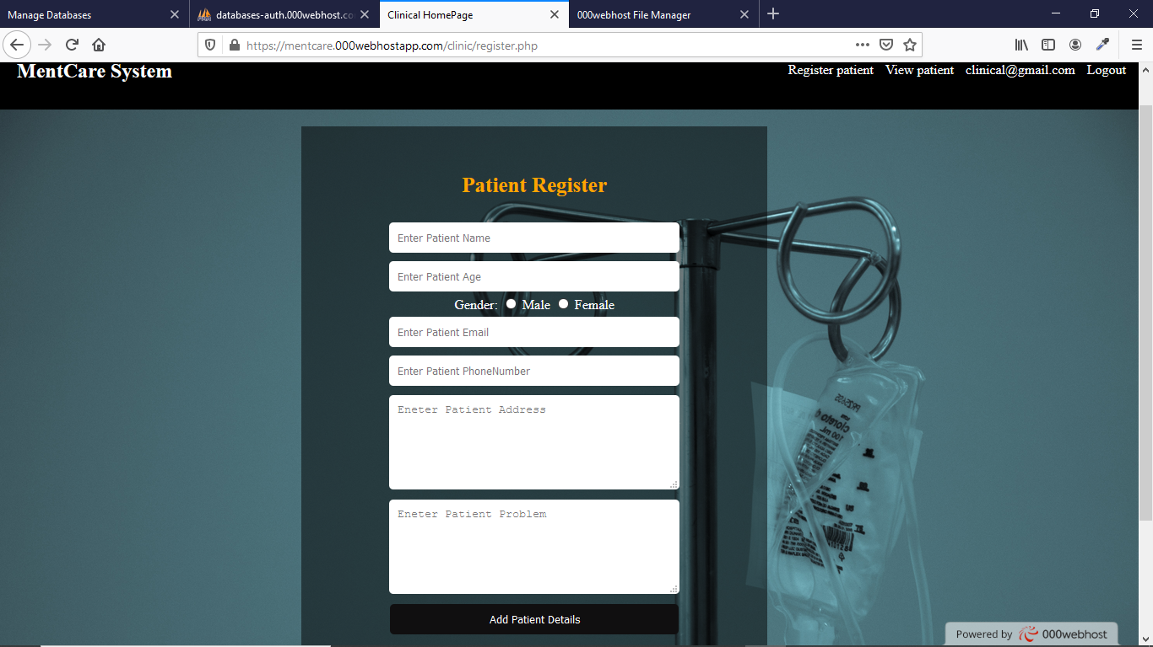

In this page clinical staff can add the patients and their details.

**VIEW PATIENTS:**

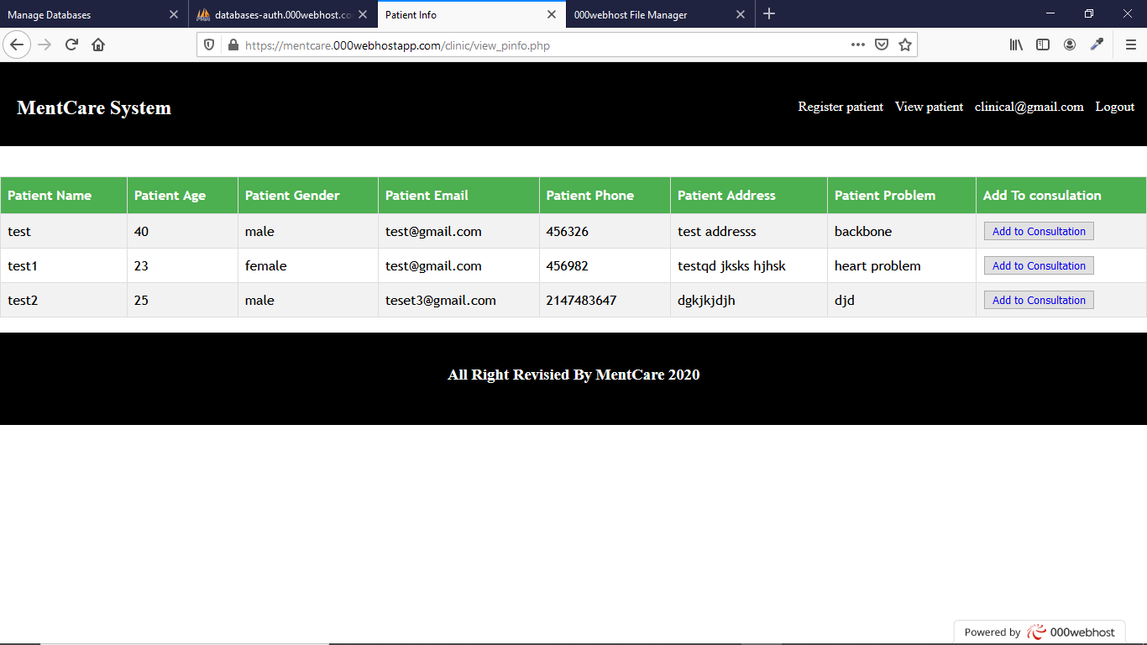

In this page clicnical staff can view the patient’s details and make their consultant to desire doctors or specialist.

**CONSULTANT PAGE:**

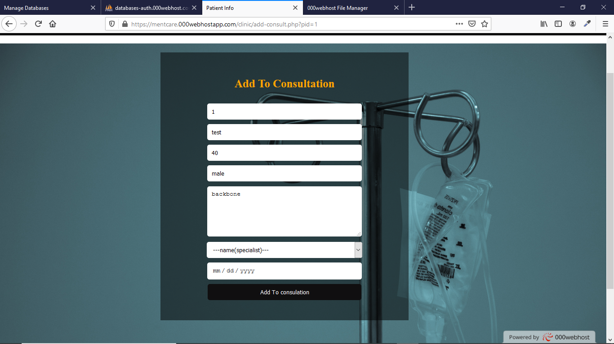

**ADMINSTRATOR MODULE:**

**INDEX PAGE:**

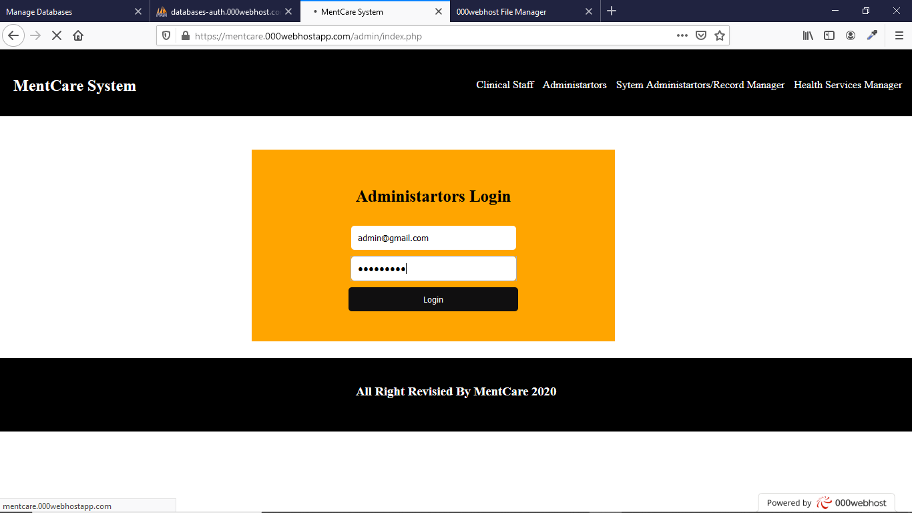

This index page of admin he can login to their module from this page. He/she also have authentication details through we can login into admin index page.

**ADMIN HOME PAGE:**

The admin have some operation he can work like

View appointments, reschedule the appointments, and cancel the appointments.

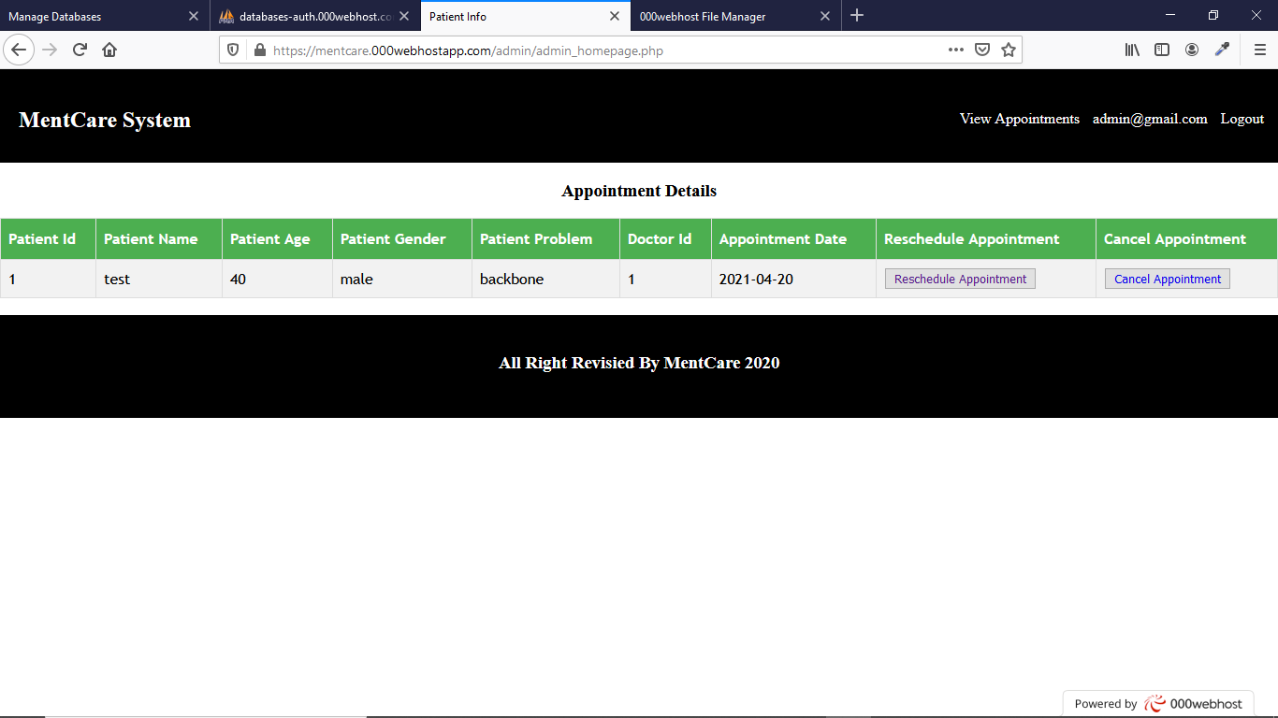

**RESCHEDULE APPOINTMENT:**

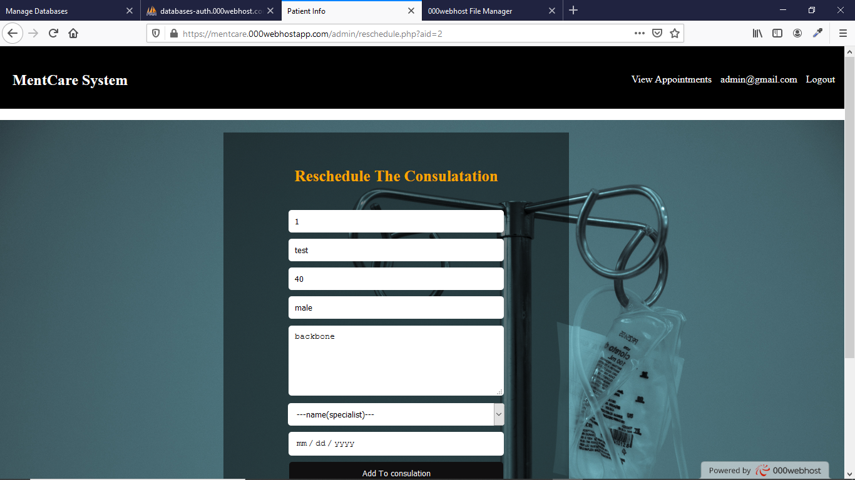

Here patient appointment can be reschedule by the admin.

**RECORD MANAGER MODULE:**

**INDEX PAGE:**

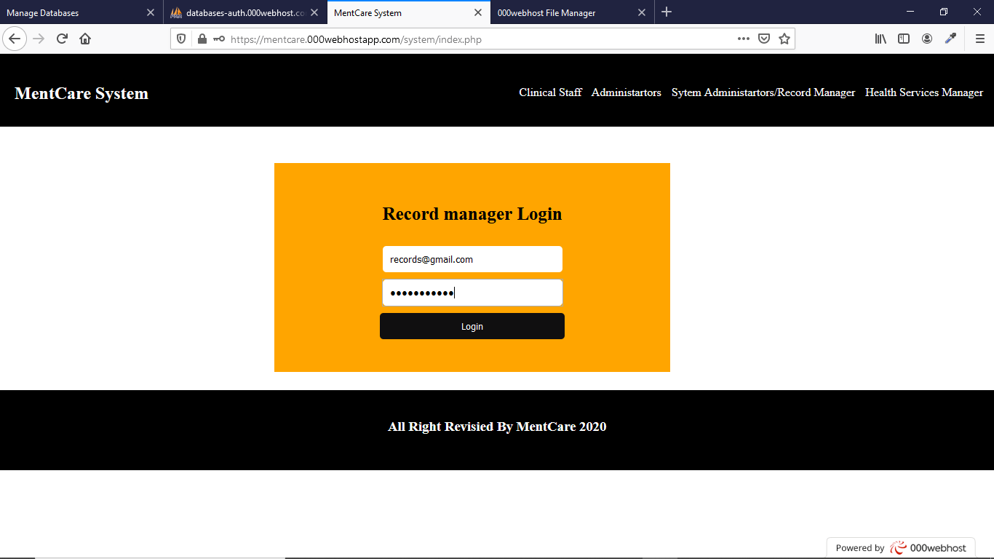

This was record manager index page. Record manager has a authentication details through he/she can login into their module.

**RECORD MANAGER HOME PAGE:**

He/she has some specific operations which have to work on like:

View patients details, view appointments, view doctors

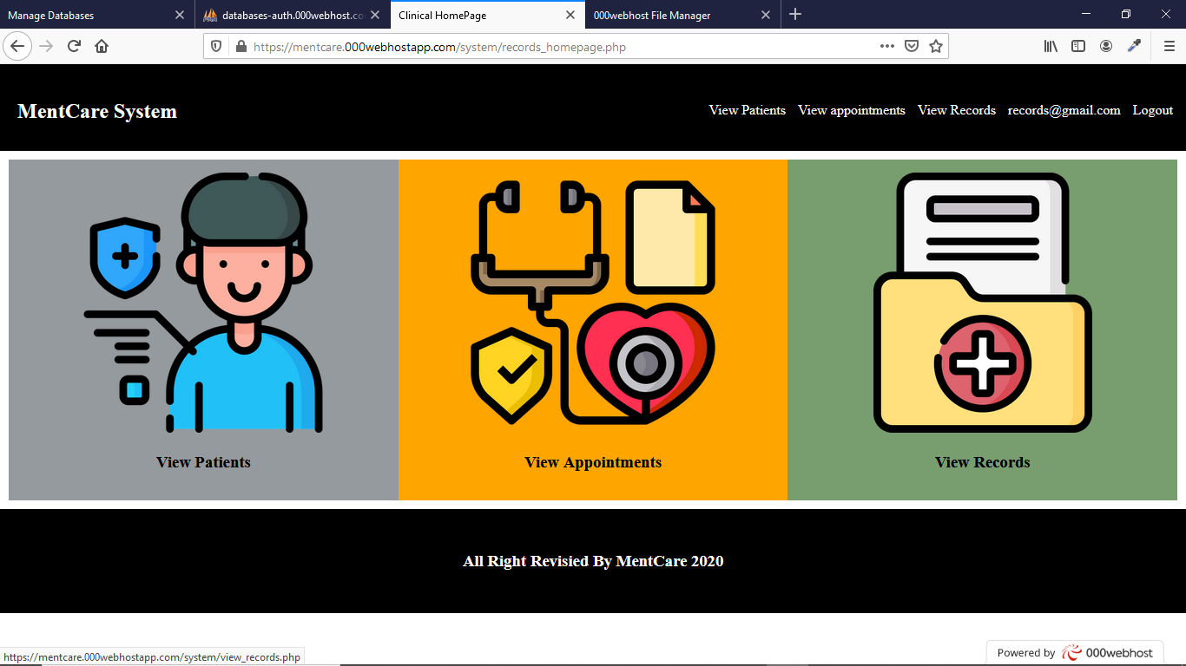

**VIEW PATIENTS:**

The record manager can view patient details in this page

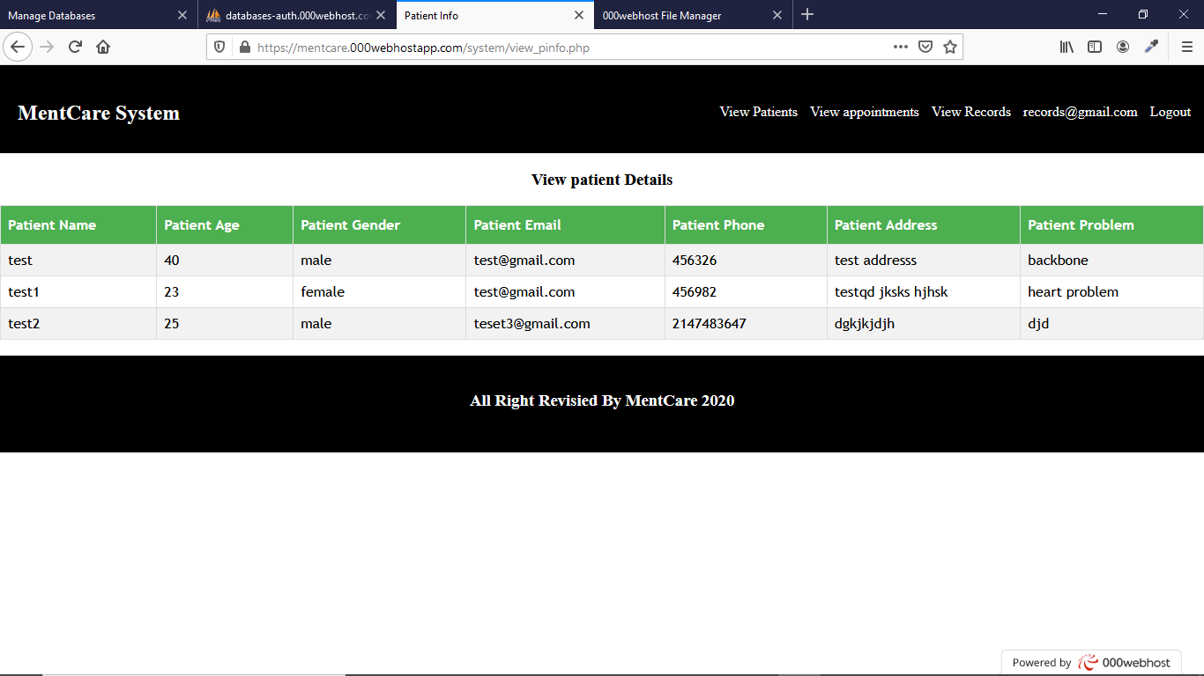

**VIEW APPOINTMENT:**

Record manager can view the all appointments in this page

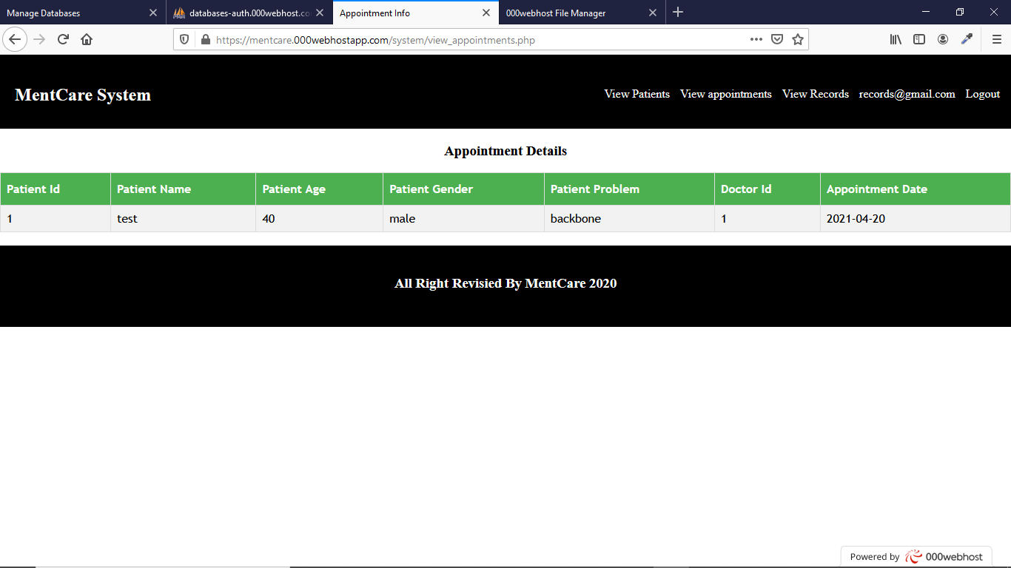

**VIEW DOCTORS:**

Record manager can view the details of doctors

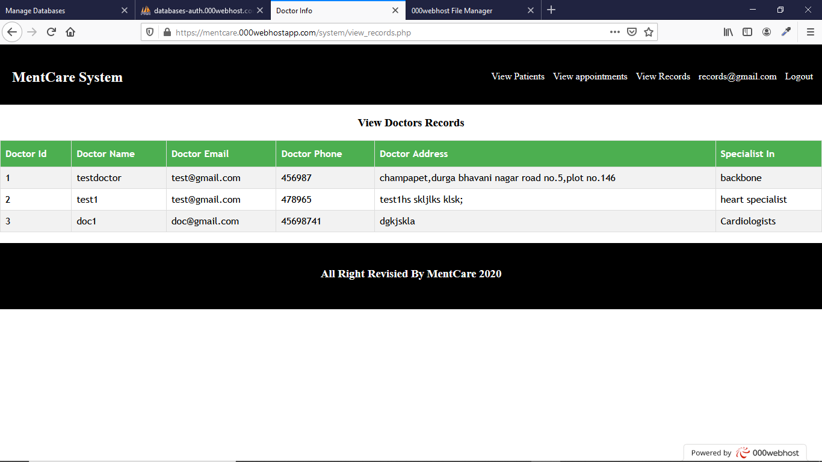

**HEALTH SERVICE MANAGER:**

**INDEX PAGE:**

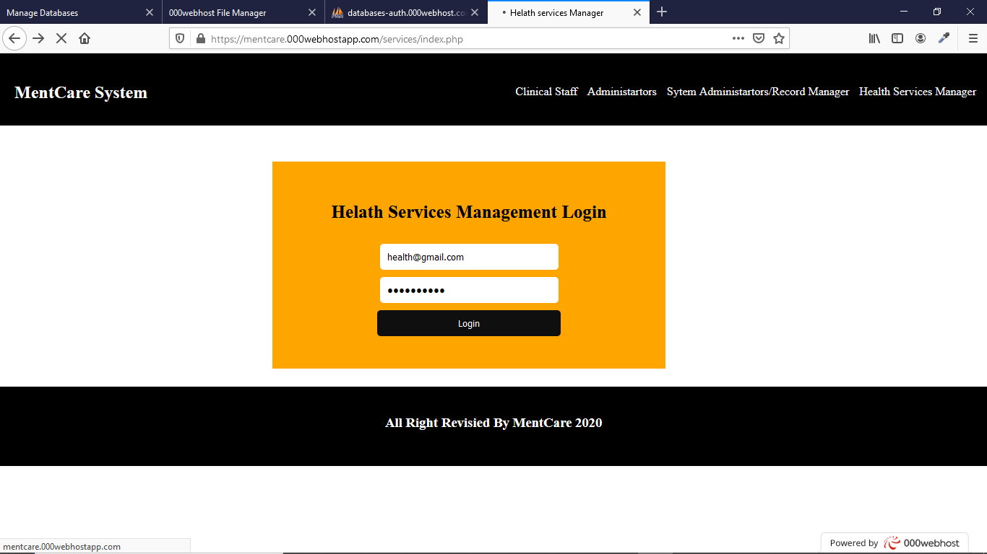

**SERVICE HOME PAGE:**

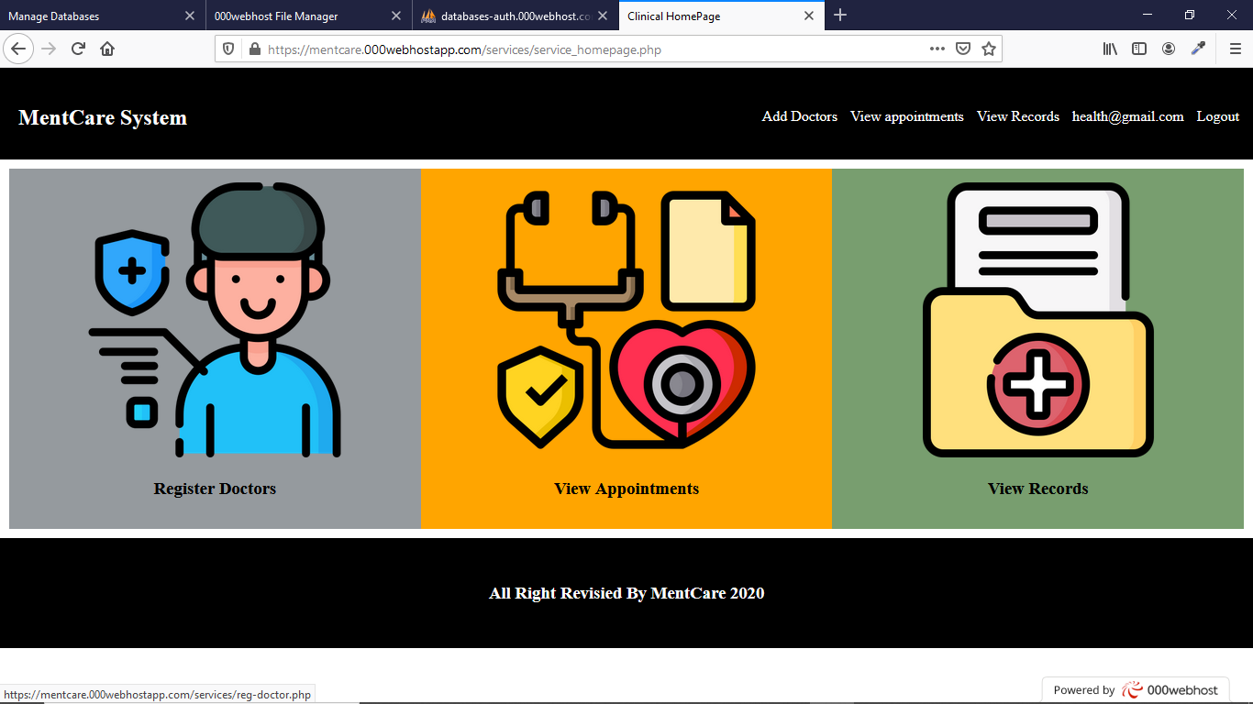

For health service manager has some operations like

Register doctors, view appointments, view doctors

**REGISTER DOCTOR:**

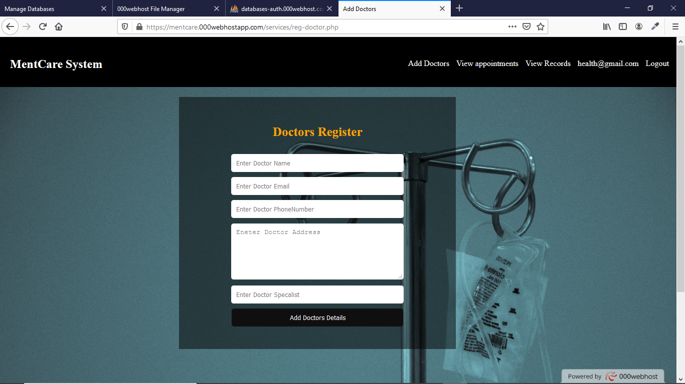

Health service manager can add the doctor’s details using this page.

**VIEW APPOINTMENT:**

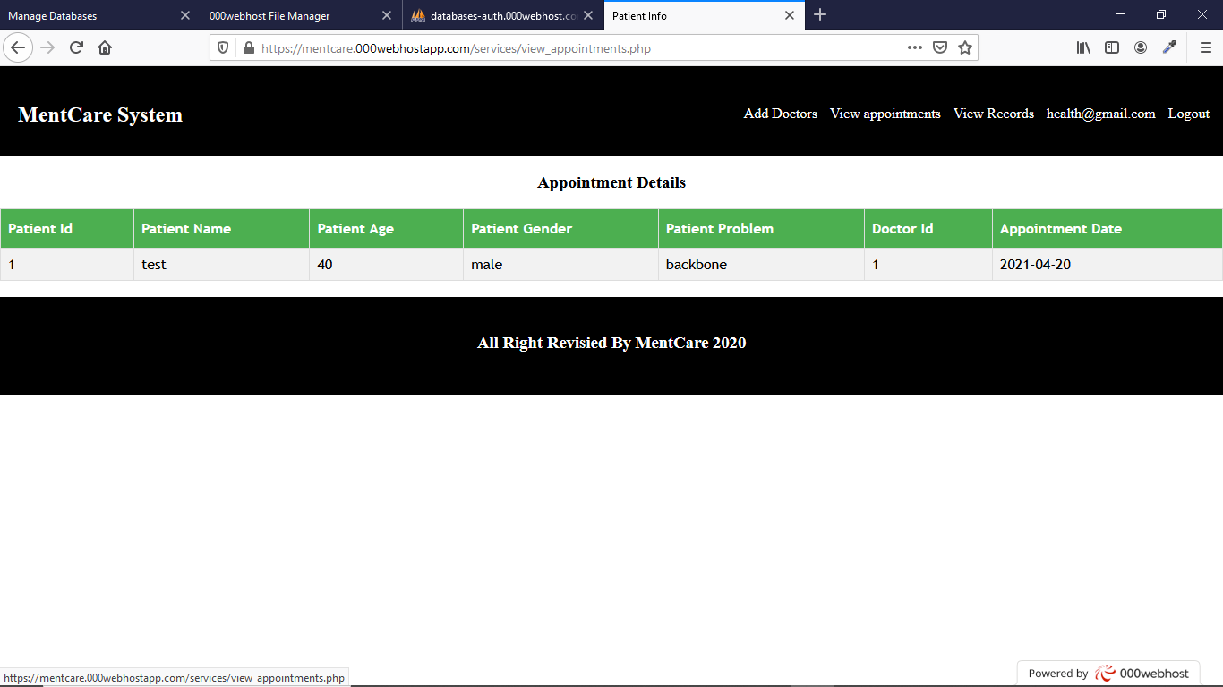

**VIEW DOCTORS:**

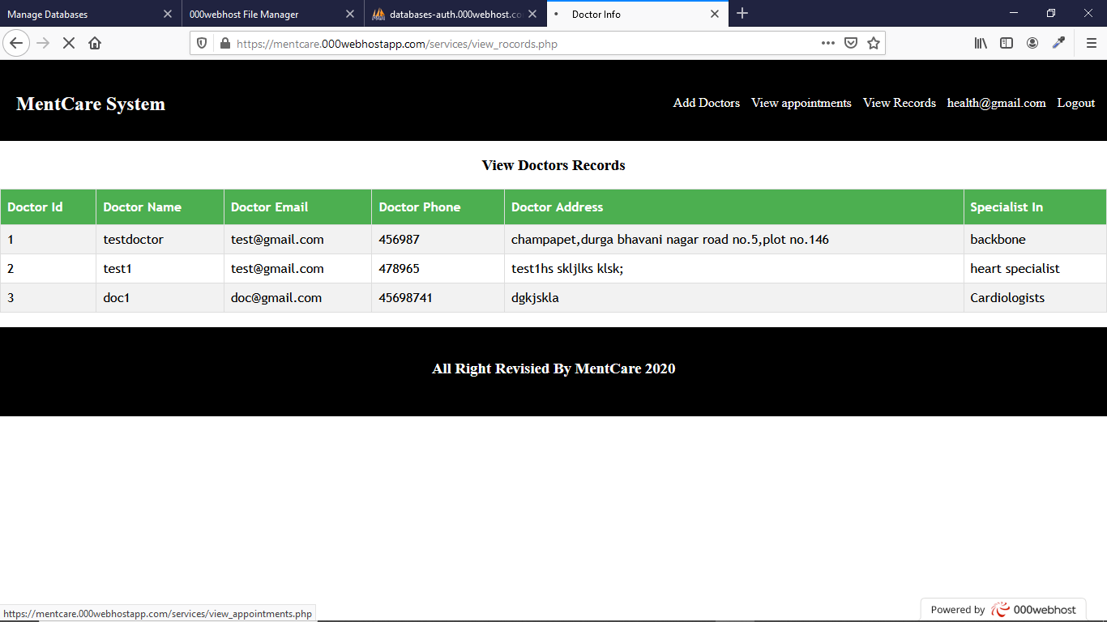

**DATABASE STRUCTURE:**

The entire database play important role in this project. It used to store all users’ data, and retrieve from database. It has a multiple table in this project to store.

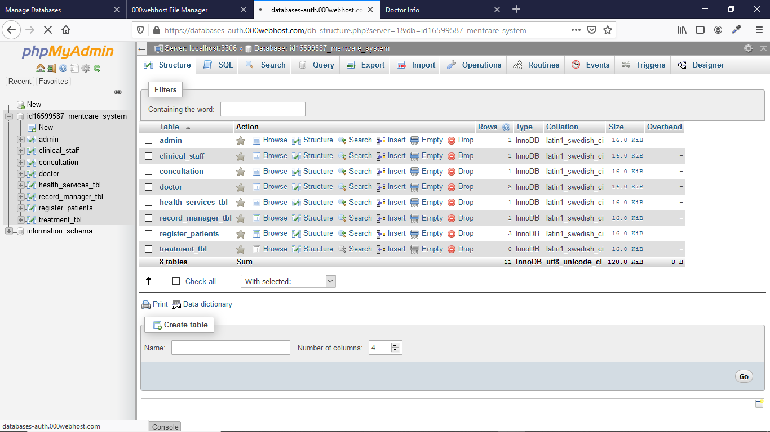

**Alpha Release:**

In the agile software development life cycle, alpha release takes place first in the software testing. In this release developer generally test the white-box technique. Also developers can perform the black-box testing.

In this release main focused on the serious errors in the product. Alpha release doesn’t have all the features that are planned to release in the final release. It is the first end-to-end testing of a product to ensure it meets the business and requirements and functions correctly. It emulates the real-user environment, through black box testing and white box testing approach. It ensures the software works uniformly, delivering optimal user experience. It helps to find out and rectify bugs that are missed by previous tests. It allows team to test the software in a real world environment. Alpha testing validates software quality , effectiveness, and functionality before its release.

**Beta Release:**

This release followed by the alpha release. In this release try to find the unknown error, its mainly focused on the speed, perform, check is there any data leakage, and any crashes of code. The process of the delivering the product of a beta version to user is called beta-release. The beta release can be tested on the client systems. It can be tested product on private or public, with limited users. In these stage developers received a lot of modification from users.

Beta testing is a Type of user acceptance testing among the most crucial testing, Beta testing is a type of Field Test. It validates the usability, functionality, compatibility, and reliability testing. The product is tested by the user in real time to find bugs that are left to be fixed. Beta testing is also used to determine quality of product and it includes testing generally by public then it known as Open Test.

**Final Release:**

The final release testing phase is also called ‘Gamma Testing’ It is done when the software is ready of release with specified requirements, no feature development or enhancement of the software is undertaken and foldly scoped bug fixes are the only code.

In this release we check the project security and speed of the project, all features of the site are well designed, coded and check any bugs occurred in any release. It was checked by the developers and tested by the testers then the entire project file will be released to the final production. We also cover release testing of the modules in the final release.

In these releases still, the source code can be changed if any bug occurs. The test conducted in client locations and the test the project from client perspective.

Then project will be in the live after clearing the bugs in this release. It’s ready to use the project in the real time.

**The difference between alpha, beta, and final releases**

|  |  |  |
| --- | --- | --- |
| ALPHA RELEASE | BETA RELEASE | FINAL RELEASE |
| Alpha Release, in this release the project can be tested by the testers. | Beta Release, in this release the project can be tested by the clients and end-users. | Final Release, in these releases we focused on the accuracy result. |
| It can test project in the developer sites. | The project tested in the client environments. | In this release, the project real-time servers. |
| It validates the software in all perspective, ensure readiness for beta testing. | In this, it get end users feedback, ensure readiness for release. | It will check the software accessible to the specified requirements |
| This will illustrate by in-house development or Quality analyst team. | This will be done by group of real and end users. | This process will be processed by limited number of end users |
| In this process will rectify bugs, blockers, missing features and others. | To get ideas to improve usability, functionality and compatibility | In final release to get for updates in upcoming version of the product. |

**Client signed acceptance of the FINAL-release**.

We made all the changes from the iteration- 3. They are nothing to change from the application we design and produce the application based on the requirements. In the iteration-3 we tested the beta-release.

**Final-release:**

In this release we check the project security and speed of the project, all features of the site are well designed, coded and check any bugs occurred in any release. It was checked by the developers and tested by the testers then the entire project file will be released to the final production. We also cover release testing of the modules in the final release.

In these releases still, the source code can be changed if any bug occurs. The test conducted in client locations and the test the project from client perspective.

This letter to accept the final release of the project.

[Sender. Company]—Students Details

Signature

MM/DD/YYYY

[Sender.FirstName] [Sender.LastName]

[Client.Company]-- Client Details

Signature

MM/DD/YYYY

[Client.FirstName] [Client.LastName]

**Provide the burn-down and velocity charts/values for all iterations.**

Burn-down and velocity charts/values for all the iterations

In the iteration 1 and 2

Total working days = 40 (10 days for person)

Total velocity days = 40

Feature velocity = 60%

Bug allowance = 40%

Capacity of works days = 42

In the iteration 3

**Working days =40 (14 days per person)**

**Total velocity =40 days**

**Feature velocity 60%**

**Bug allowance 40%**

**Capacity of work = 42 days**

All iterations values:

Total working days = 80 (24 days per person)

Total velocity days = 80

Feature velocity = 60%

Bug allowance = 40%

Capacity of work days = 84

**Demonstrate the Project development and release ICT infrastructure:**

**Development environment:**

We developed this project on the visual studio code IDE. It was one of the best editors for web site development. That’s why we choose the visual studio code.

**Programming Languages:**

At present modern era, most of the website are written in PHP are written in some sort of a MVC or MVT framework, However the lot of geeks are just getting started with PHP and while then try to get some ort idea to develop new PHP projects. There is some struggle in initial stage of maintaining project, Maintaining an core PHP will be very tougher job.

Initially you should create an specific folder structure , I likely to recommend breaking your project into 4 folders:

* Assests
* Helpers
* Views
* Process
* .htaccess
* Index.php

**Assests:** This folder will contains all asset files, style sheets, Images, and JavaScript files and make separate directories for each type of other files.

**Helpers:** It will contain some specific functions which all the files would be using, the best example is database connection.

**Views:** The “views” will contain which is basically means these files are showing some form of web page.

**Process**: It will contain and allows all the process and all files than handle form of submissions and other form of processes. It will have three step process: input>process>redirect.

**htaccess:** This file used for the configuration for php. It file has one or more configuration directives that available in particular directive. It has file like .config that help change and add configuration for the project.

**index.php:** This file was used as landing page for a website.

**Source code repositories:**

To maintain the project, the source code repositories play important role. It will store the project files and connective with web servers. It helps the project to run in the real-time. It will provide services like PhpMyadmin Database, Storage Space, Webmail accounts and security to for domains.

They are some code repositories like:

GitHub, Bitbucket, SourceForge, GoDaddy, hostinger and etc.

**Project collaboration tools:**

We used multiple tools for sharing files and communication between our team members.

Tools:

GoogleDrive: GoogleDrive used to share the files between our team members. All files are available on google drive.

ZOOM: ZOOM used to share ideas and communication among us.

**Development Tools:**

We used different types of development tools like:

HTMl5:

Html used to create web pages. Html stands for Hyper Text Markup Language. It was all about the structure of the web page. The html used to display content on the browser.

CSS3:

CSS stands for Cascading style sheet. It was used to add styles to the web pages. It tells the browser how to display the html page on the browser. It can control the layouts of the web pages.

**Client testing and access to the Release**

**Domain Name:** <https://mentcare.000webhostapp.com/>

Mentcare in 000webhostapp

**Domain hosting site:** 000webhostapp

**Client training document and procedure:**

We create account a free hosting account in the 000webhostapp. They provide us cpanel details with this details we login into the 000webhostapp. In the cpanel home page will be the your dashboard. In the dashboard you available to see the status of web site.

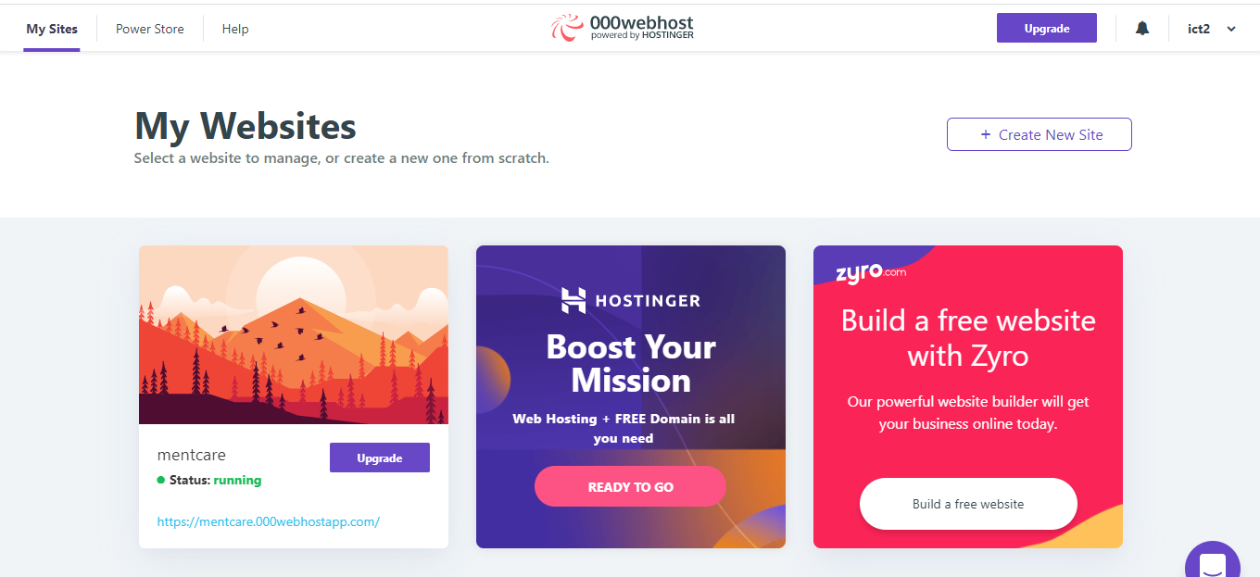

Then go to the mentcare then it will have hover button like manage website. Then click on it. It will take you to mentcare dashboard.

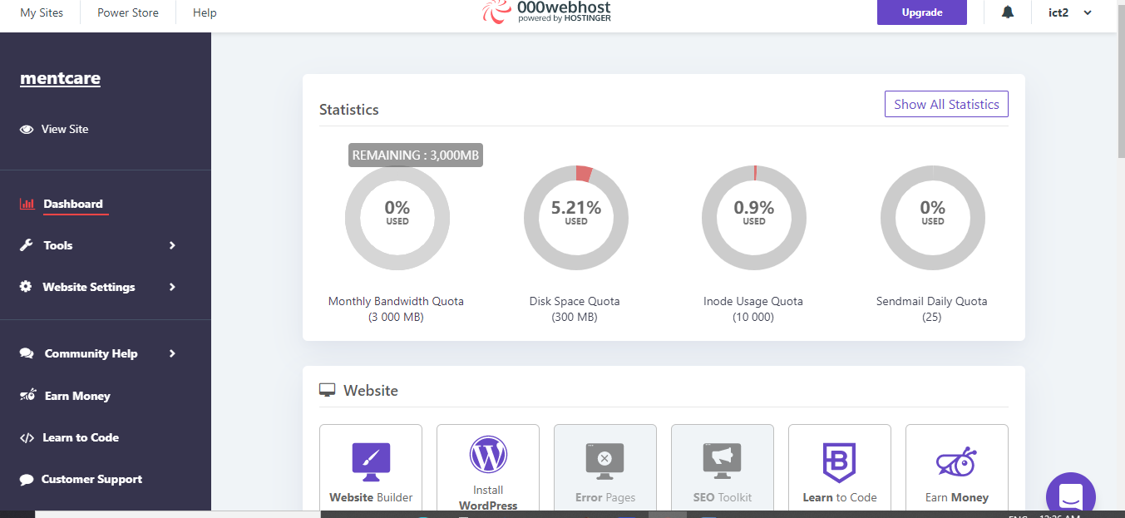

It will provide you the free database, free disk space upto 300 mb, free mails. It will shows the usage of disk space and sended mails.

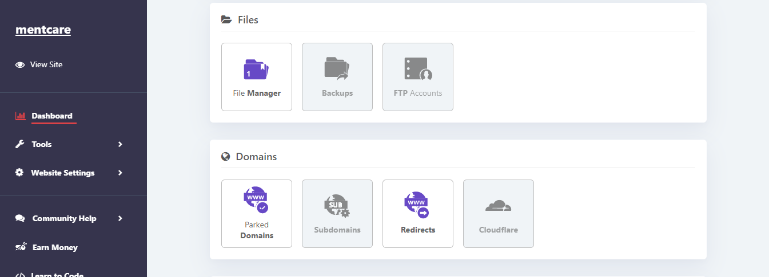

In the file block, we will find the file manager. Click on it. It will redirect the page to file system of the mentcare.

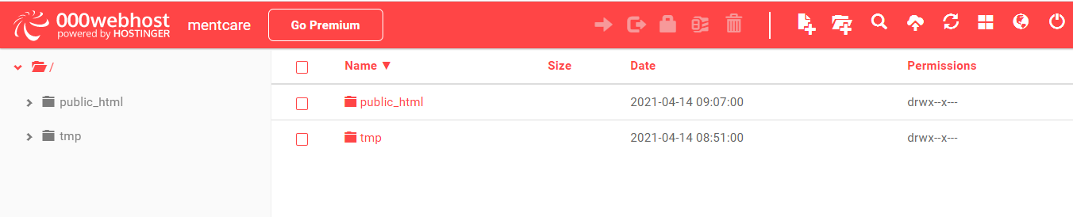

We will find the public_html folder in that folder we will have the all the project related files in those directive.

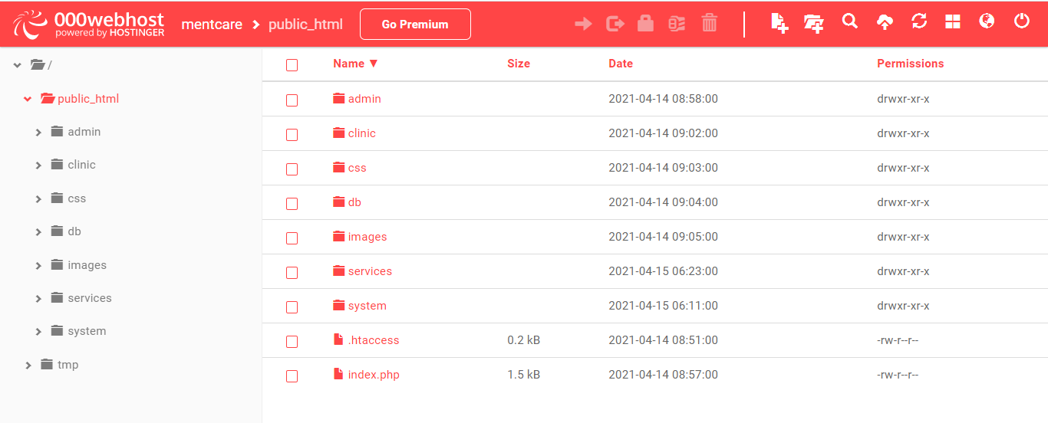

These are all the files that related to the project. in these folder we have index.php

These file used as landing page of the project.

Css folder: In this folder all CSS files are available that we used in this project

Db: In this folder, database connectivity file is available these used connect with the database.

Images folder: In this folder, all the images that are used in the landing page.

We divided the project into 4 modules.

1. Administration (admin folder): In this folder, all files related to the admin like css, images, and php files
2. Clinical Staff (clinic folder): in this folder, all files related to the Clinical staff like css, images, and php files
3. Record Manager (sysem folder): In this folder, all files related to the Record Manager like css, images, and php files.
4. Health Services Manager (services folder): In this folder, all files related to the Health services manager like css, images, and php files

It will also provide the free data base. I used the phpmyadmin. Goto the databases in the block we will find the phpmyadmin. Click on it.

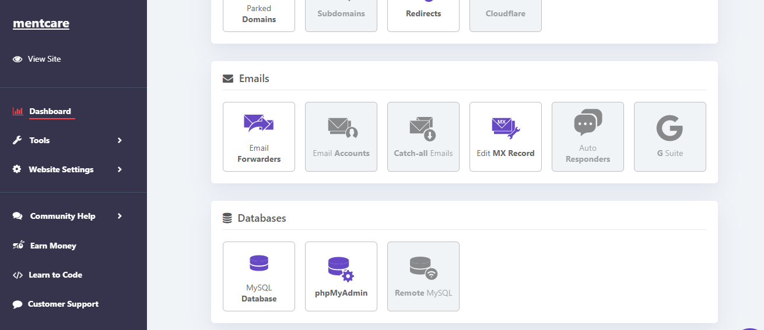

It will open the mange database page. Like this:

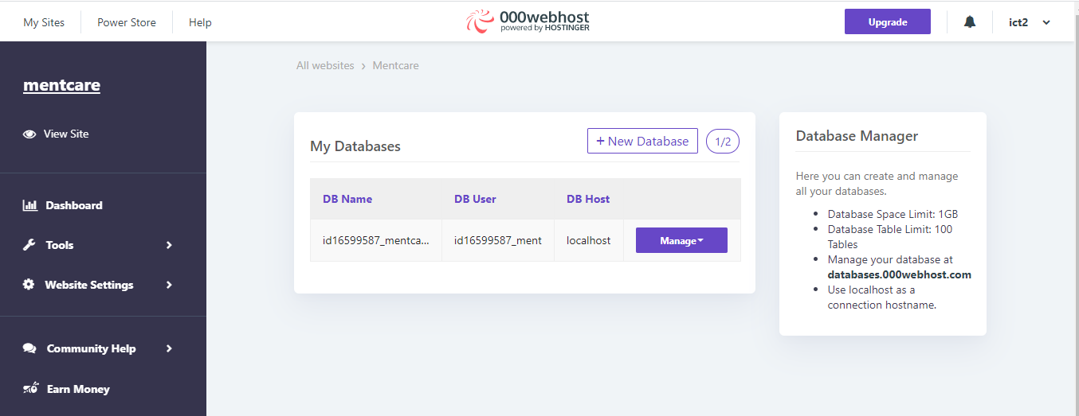

In that we find the manage button click on it. It will redirect to the phpmyadmin database.

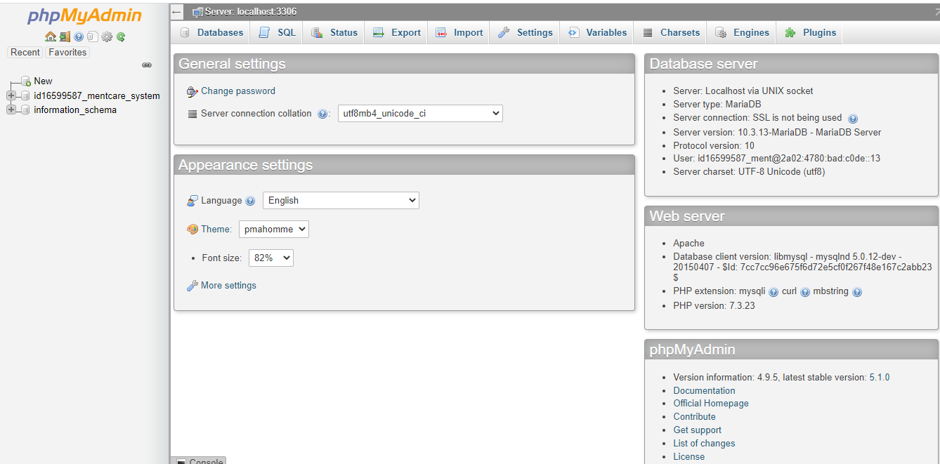

Left side will find idwith some value_mentacre_system click on it.

It open the database table that are used in the project:

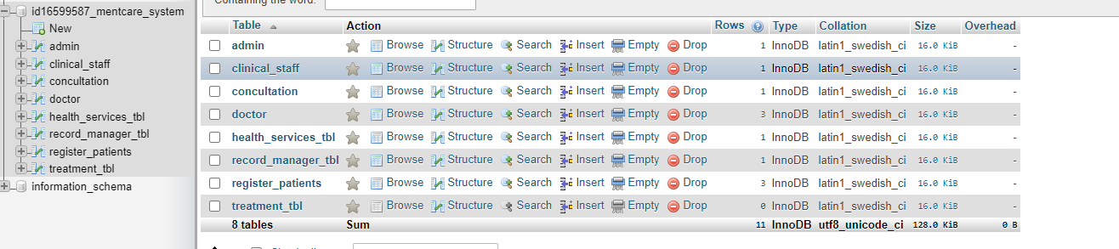

These are the table which used for the project. when click on the table names it will open the data.

